

Functional Specification
MESSENGER

Version 1.4
Last modified 21 Aug 2019
Number of pages 8
Document History
Date | Description | Author(s)
04-Feb-09 | Version 0.01: created the initial version of the doc. | Emma
15-Jan-10 | Version 0.02: the initial version is moved to the new version of text document template | Ruben
19-Jan-11 | Version 0.03: added sections “Use Cases Coverage”, “Questions and Answers”, removed section “Current Status” | Hovhannes A.
31-Jan-2013 | Version 1.0 changed formatting according to text document template version | Arman
10-Mar-2015 | Changed the ISO 9001 certificate logo. Approved version 1.1. | Syuzanna
28-Oct-2015 | Approved version 1.2: Changed the Company logo and name from Instigate CJSC to Instigate Design CJSC. | Syuzanna
25-Aug-2016 | Version 1.2.1: Added descriptions for part of the sections. | Emma, Anna D.
05-Oct-2016 | Version 1.2.2: Added descriptions of the sections. Added space after numbering as it is in other template documents. | Emma
19-Dec-2017 | Version 1.2.3: Revisited headings. | Anna Sh.
02-Feb-2018 | Approved version 1.3. | Anna Sh.
04-April-2018 | Approved version 1.4. Changed ISO 9001 certificate logo. | Syuzanna

Table of Contents
1. Introduction 4
1.1. Document Identifier 4
1.2. Scope 4
2. Problem Statement 4
3. Overview of Solution 4

Introduction

Document Identifier
This is a functional specification document for “MESSANGER” project.
This document includes the functionality of the project and a step-by-step description of the working principle.

Scope
This section helps the reader to find the appropriate section, it serves as the content navigation.
Project working steps
3.1 | Server working principle
3.1 | The first wndow working principe: Welcome cliend and suggest login or registration
3.2 | Client registration form description
3.3 | Client login form description
3.4 | Client connecting server with hostname and port number action description
3.5 | Chatting window (client-server-client) working way for clients (users) description

Problem Statement
Here is a description of the working principle of the product. How our messenger is work.
The first opens welcome window, where we have two buttons: first login and second registration.
Then separate windows open login and registry windows. By typing in your username and password, you can enter the chat, and you can register in system,then write login and password and enter the chat. Finally by logging in we will be able to write a message to another user and receive message from others.

Overview of Solution
This section should briefly define the supported functionality, the description can be presented visually by diagrams or illustrations of the functional structure and supported actions. For a GUI project this can be mock-ups of the developed graphical applications.

3.1. Server working principle
The first wndow working principe: Welcome client and suggest login or registration

When we run server code with port, server can listen clients, and when run client side code too open the first Welcome messenger window. Where we have 2 buttons, one for login system (chat) and second for registration.
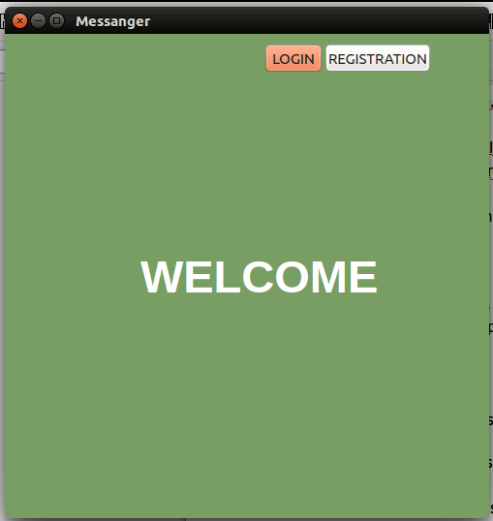

3.2. Client registration form description
When we clicked in “REGISTRATION” button open registration window, where we can registrate. Forexample:
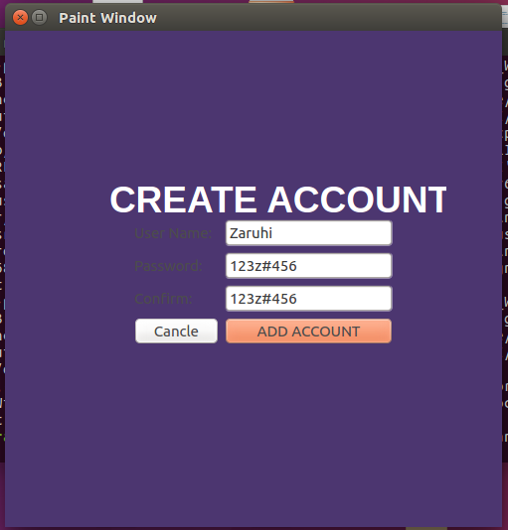

When we registrate correct: Username should be only lowercase and uppercase, and password should be not little then 6 simbol: any letter, number or different simbols.

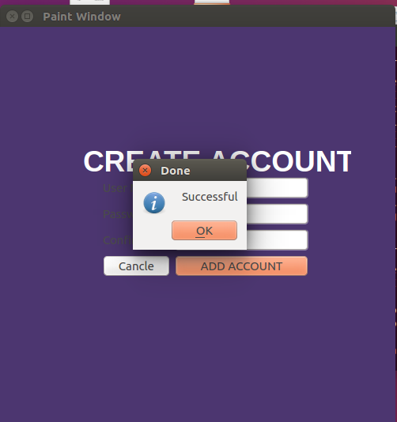

3.3. Client login form description

After Registration clients (users) registration data save in file, and open login window, that have Username and passwd field and client can everytime login.
If you don’t want login, you can press “Cancle” button and go back in the first “Welcome” window.

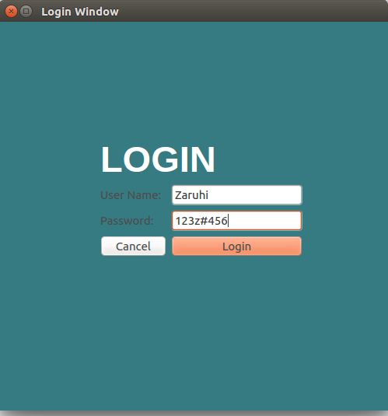

3.4. Client connecting server with hostname and port number action description

After login with Username and passwd, open other window: connecting server with hostname and port which listen server and clicked connect button.
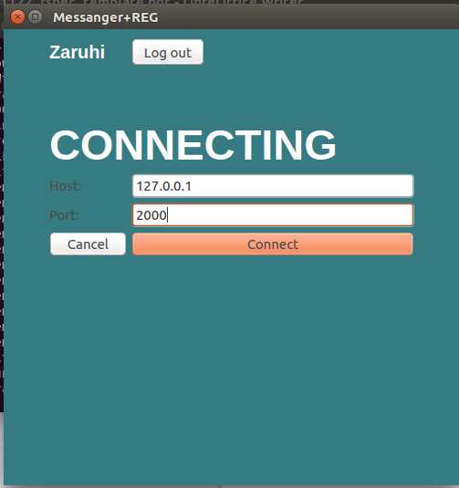

In Host LineEdt we can write hostnames whiche there are in /etc/hostname file or write 127.0.0.1 local host addres, and port include 2000-65535 numbers range, If you don’t connect you can clicked Cancle button and come back log in window.

3.5. Chatting window (client-server-client) working way for clients (users) description

After connecting open chatting window, where clients(users) can write each other message, can see online users list in there chat and finally every client (user) can logout from messanger, came back again and countinue chatting.
